**Azure Website Deployment**

**Using**

**Release Management**

Logesh Rajamanickam

12-19-2014

**Release Management - Azure Website Deployment**

This document will explain about the azure website deployment using Microsoft “Release Management” tool. The below steps has to be followed to automate the azure deployment along with the TFS build.

**Project & Build definition configurations:**

**Step 1:** Create publish package profile for the website deployment

**Ref:** Publish profile: ***Jarvis-Package-Azure***

**Step 2:** Create PowerShell script to copy website publish scripts to the build drop folder

**Ref:** Copy script: ***$/Jarvis/Source/Dev/WebSite/PublishScripts/PublishScriptCopy.ps1***

**Step 3:** Create build definition using “***ReleaseTfvcTemplate.12.xaml***” build template

**Ref:** Build definition: ***Jarvis.WebSite_Azure_Release***

**IMPORTANT:** Configuration for build package, copy publish scripts

Set “MSBuild arguments” : “***/p:DeployOnBuild=true;PublishProfile=Jarvis-Package-Azure***”

Set “Post-build script path”: “***$/Jarvis/Source/Dev/WebSite/PublishScripts/PublishScriptCopy.ps1”***

Set “Release Build” : “**True**”

**Release Management - configuration:**

**Step 1:** Create “Tool” for azure website deployment. (It was created and available in the tool, so no need to create new tool. Use the tool “**Azure Website Deploy**” for any azure website deployment.

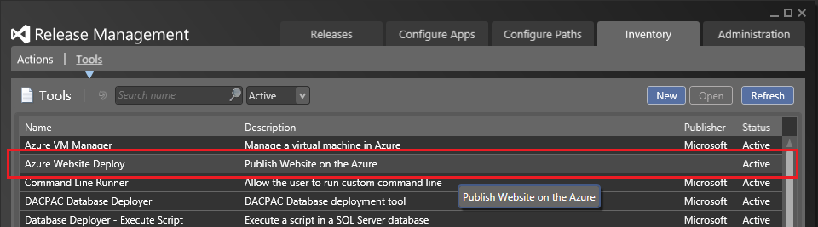

**Step 2:** Create new “Component” for your project deployment.

**Step 2.1:** Add build drop path

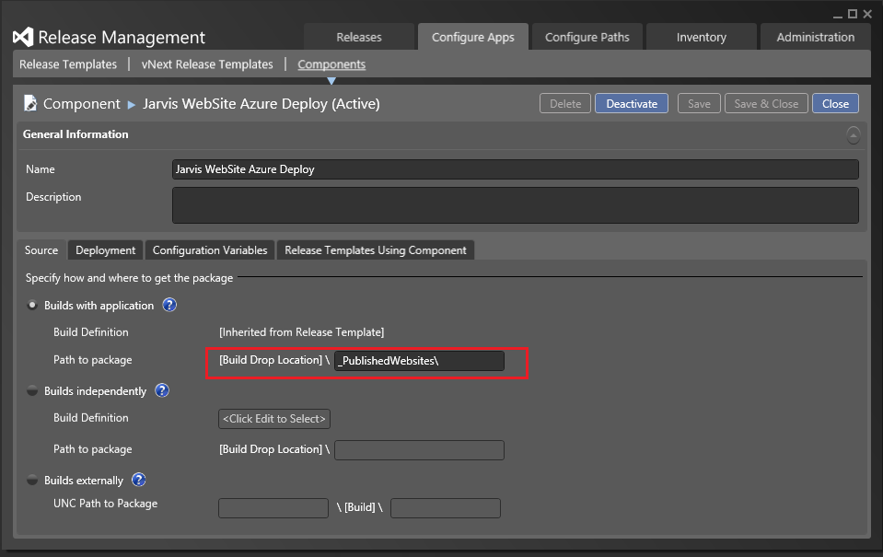

**Step 2.2:** Choose deployment tool “Azure Website Deploy”

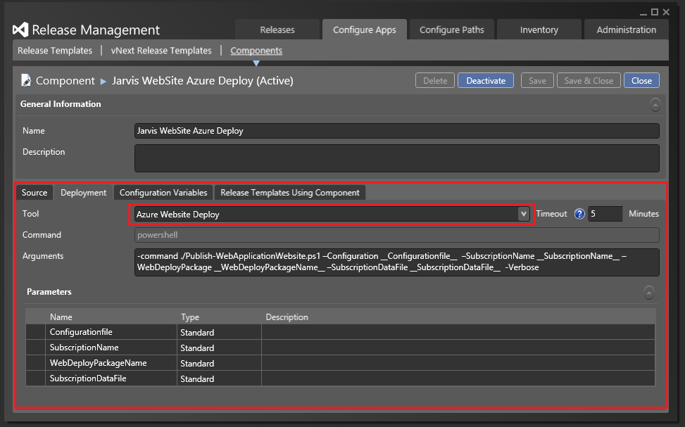

**Step 2.3:** Add the configuration variables

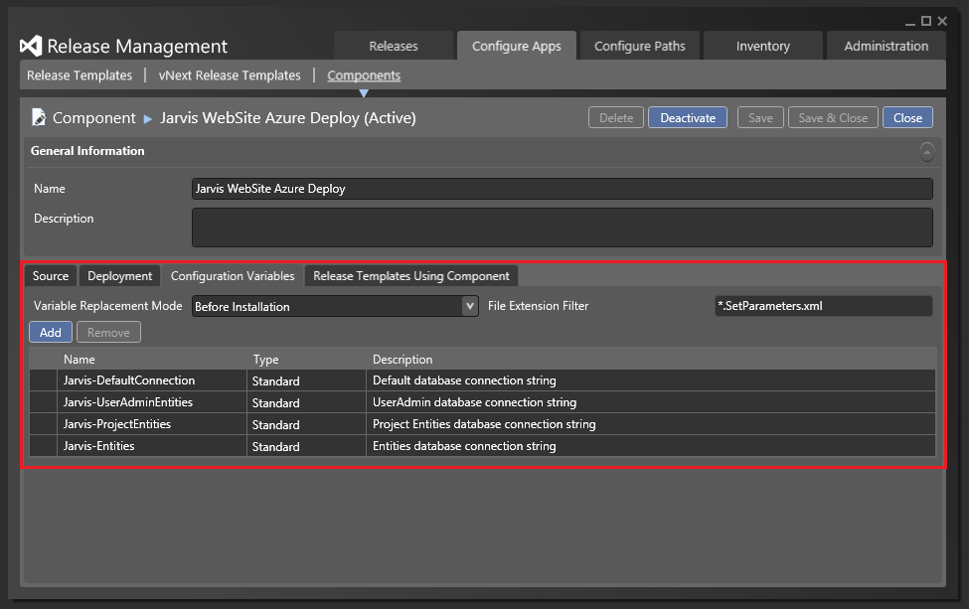

**Step 3:** Createnew “Release Template” and choose build defination

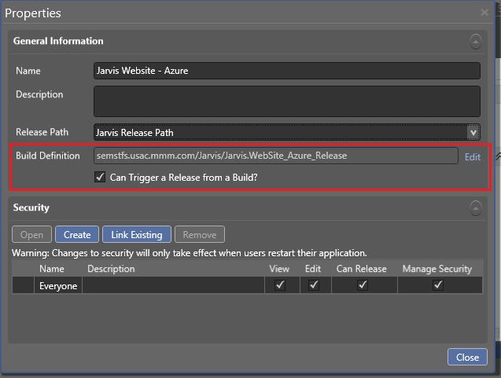

**Step 4:** Add deployment sequence

**Step 4.1:** Add copy file/folder step

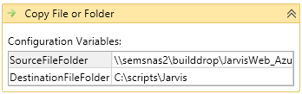

**Examble:**

**SourceFileFolder**: \\semsnas2\builddrop\JarvisWeb_Azure\Deploy\PublishScripts (The folder which was used to copy the publish script file using powershall script in the intial configuration.

**DestinationFileFolder:** c:\scripts\Jarvis (to copy the files from the build drop location to local forlder to use the scripts/files for azure deplyment

**Step 4.2:** Configure deployment variables

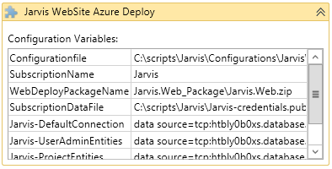

**Examble:**

**Configurationfile:** “C:\scripts\Jarvis\Configurations\JarvisWeb-WAWS-dev.json”

**SubcriptionName**: Jarvis

**WebDeployPackageName:** Jarvis.Web_Package\Jarvis.Web.zip

**SubscriptionDataFile:** C:\scripts\Jarvis\Jarvis-credentials.publishsettings

**Jarvis-DeafultConnection:** <database connection string>

**Jarvis-UserAdminEntities:** <database connection string>

**Jarvis-ProjectEntities:** <database connection string>

**Jarvis-Entities:** <database connection string>

**Step 4.3:** Add step to delete the temp files copied to local machine for deployment

